**Spinal Care Associates**

**Patient Health Information Consent Form**

We want you to know how your Patient Health Information (PHI) is going to be used in this office and your rights concerning those records. Before we can begin any health care treatment we need you to read and sign this consent stating that you understand and agree with how your records will be used. If you would like to have a more detailed account of our policies and procedures concerning your Patient Health Information, we encourage you to read the HIPAA NOTICE that is available to you at the front desk before signing this consent.

1. The patient understands and agrees to allow this Chiropractic office to use their Patient Health Information (PHI) for the purposes of treatment, payment, healthcare operations, and coordination of care. As an example, the patient agrees to allow this Chiropractic office to submit requested PHI of the Health Insurance Company (or companies) provided to us by the patient for the purpose of payment. Be assured that this office will limit the release of all PHI to the minimum needed for what the insurance companies require for payment.

2. The patient has the right to examine and obtain a copy of his or her own health records at any time and request corrections. The patient may request what disclosures have been made and submit in writing any further restrictions on the use of their PHI. Our office is not obligated to agree to those restrictions.

3. A patient’s written consent need only be obtained one time for all subsequent care given to the patient in this office.

4. The patient may provide a written request to revoke consent at any time during care. This would not affect the use of those records for care given after the request has been presented.

5. For your security and right to privacy, all staff has been trained in the area of patient record privacy and a privacy official has been designated to enforce those procedures in our office. We have taken all precautions that are known by this office to assure that your records are not available to those who do not need them.

6. Patients have the right to file a formal complaint with our privacy official about any possible violations of these policies and procedures.

7. If the patient refuses to sign this consent for the purpose of treatment, payment and health care operations, the Chiropractic Physician has the right to refuse given care.

I have read and understand how my Patient Health Information will be used and I agree to these policies and procedures.

____________________________________________________ ___________________

Signature of Patient/Parent or Guardian Date

Office Policy

We invite you to discuss frankly with us any questions regarding our services. The best health services are based on a friendly, mutual understanding between provider and patient.

Our office policy requires payment in full for all services rendered at the time of your visit, unless other arrangements have been made. If your account is not paid within 90 days from the date of service, and no financial arrangements have been made, you will be responsible for any expenses incurred in collecting on your account.

Authorization and Assignment of Benefits

I hereby authorize payment of benefits directly to provider of benefit due for services rendered. I further authorize the physician and/or supplier to release any information required to process insurance claims.

I also understand it is my responsibility to inform this office of any changes in my medical status or insurance. The information that this office has is correct to the best of my knowledge.

Signature of Responsible Person: ______________________________________

Print Name: _______________________________________________________

Date: ____________________________________

Allergy Name (latex, lidocaine, medications, food, etc.): Reactions and Symptoms:

____________________________________________ ________________________________________

____________________________________________ ________________________________________

____________________________________________ ________________________________________

____________________________________________ ________________________________________

[Type a quote from the document or the summary of an interesting point. You can position the text box anywhere in the document. Use the Drawing Tools tab to change the formatting of the pull quote text box.]

[Type a quote from the document or the summary of an interesting point. You can position the text box anywhere in the document. Use the Drawing Tools tab to change the formatting of the pull quote text box.]

[Type a quote from the document or the summary of an interesting point. You can position the text box anywhere in the document. Use the Drawing Tools tab to change the formatting of the pull quote text box.]

[Type a quote from the document or the summary of an interesting point. You can position the text box anywhere in the document. Use the Drawing Tools tab to change the formatting of the pull quote text box.]

Smoking Status: Current Every Day Current Some Days Former Never Start Year: ______ Quit Date:______

Current Medications:

1. Drug Name: ___________________________________ 2. Drug Name: _________________________________

Frequency (e.g. once daily):__________________ Frequency (e.g. once daily):__________________

3. Drug Name:___________________________________ 4. Drug Name:__________________________________

Frequency (e.g. once daily):__________________ Frequency (e.g. once daily):__________________

[Type a quote from the document or the summary of an interesting point. You can position the text box anywhere in the document. Use the Drawing Tools tab to change the formatting of the pull quote text box.]

[Type a quote from the document or the summary of an interesting point. You can position the text box anywhere in the document. Use the Drawing Tools tab to change the formatting of the pull quote text box.]

Alcohol Use:

None Light Moderate Heavy

[Type a quote from the document or the summary of an interesting point. You can position the text box anywhere in the document. Use the Drawing Tools tab to change the formatting of the pull quote text box.]

[Type a quote from the document or the summary of an interesting point. You can position the text box anywhere in the document. Use the Drawing Tools tab to change the formatting of the pull quote text box.]

[Type a quote from the document or the summary of an interesting point. You can position the text box anywhere in the document. Use the Drawing Tools tab to change the formatting of the pull quote text box.]

[Type a quote from the document or the summary of an interesting point. You can position the text box anywhere in the document. Use the Drawing Tools tab to change the formatting of the pull quote text box.]

[Type a quote from the document or the summary of an interesting point. You can position the text box anywhere in the document. Use the Drawing Tools tab to change the formatting of the pull quote text box.]

[Type a quote from the document or the summary of an interesting point. You can position the text box anywhere in the document. Use the Drawing Tools tab to change the formatting of the pull quote text box.]

[Type a quote from the document or the summary of an interesting point. You can position the text box anywhere in the document. Use the Drawing Tools tab to change the formatting of the pull quote text box.]

[Type a quote from the document or the summary of an interesting point. You can position the text box anywhere in the document. Use the Drawing Tools tab to change the formatting of the pull quote text box.]

[Type a quote from the document or the summary of an interesting point. You can position the text box anywhere in the document. Use the Drawing Tools tab to change the formatting of the pull quote text box.]

[Type a quote from the document or the summary of an interesting point. You can position the text box anywhere in the document. Use the Drawing Tools tab to change the formatting of the pull quote text box.]

Exercise: None Light

Moderate Heavy

Recreational Drug Use:

None Light Moderate Heavy

[Type a quote from the document or the summary of an interesting point. You can position the text box anywhere in the document. Use the Drawing Tools tab to change the formatting of the pull quote text box.]

[Type a quote from the document or the summary of an interesting point. You can position the text box anywhere in the document. Use the Drawing Tools tab to change the formatting of the pull quote text box.]

**Authorization for Release of Information**

Referred By:

**Other Patient Information**

Phone & Location:

Primary Care Physician’s Name:

**Primary Care Physician**

Emergency Contact Address:

Employer:

Emergency Contact Name & Phone Number:

E-Mail Address:

[Type a quote from the document or the summary of an interesting point. You can position the text box anywhere in the document. Use the Drawing Tools tab to change the formatting of the pull quote text box.]

[Type a quote from the document or the summary of an interesting point. You can position the text box anywhere in the document. Use the Drawing Tools tab to change the formatting of the pull quote text box.]

[Type a quote from the document or the summary of an interesting point. You can position the text box anywhere in the document. Use the Drawing Tools tab to change the formatting of the pull quote text box.]

Preferred Phone:

Home Work Cell

Cell Phone:

Work Phone:

Home Phone:

Zip Code:

State:

Address:

City:

Marital Status:

Single Married Divorced Widowed Other

Social Security Number:

[Type a quote from the document or the summary of an interesting point. You can position the text box anywhere in the document. Use the Drawing Tools tab to change the formatting of the pull quote text box.]

[Type a quote from the document or the summary of an interesting point. You can position the text box anywhere in the document. Use the Drawing Tools tab to change the formatting of the pull quote text box.]

Sex:

M F

Date of Birth:

Nickname:

Patient’s Last Name: First: MI:

**Patient Information**

Today’s Date:

Confidential Patient Data

For consideration which I acknowledge, I grant to Spinal Care Associates the right to use my name, image, video and audio for marketing materials such as, but not limited to, Spinal Care Associates’ website, Facebook and Instagram.

Yes No

Signature: ________________________________________________ Date:_____________________

**Release of Information**

I give Spinal Care Associates permission to talk to the following people about my records/treatment (please print):

|  |  |  |
| --- | --- | --- |
| **Name** | **Relationship to Patient** | **Best Contact Number** |
|  |  |  |
|  |  |  |
|  |  |  |
|  |  |  |
|  |  |  |

Patient Signature: _____________________________________ Date: ____________________

Patient Name (Please Print): ______________________________________________________

|  |  |  |  |  |  |  |  |
| --- | --- | --- | --- | --- | --- | --- | --- |
| **Family History** | | | | | | | |
| Please indicate which conditions exist or have existed by marking the boxes below. | | | | | | | |
|  | Self | Mother | Father | Sister | Brother | Son | Daughter |
| Arthritis |  |  |  |  |  |  |  |
| Cancer |  |  |  |  |  |  |  |
| Blood Disorders |  |  |  |  |  |  |  |
| Dementia/Alzheimer’s |  |  |  |  |  |  |  |
| Diabetes |  |  |  |  |  |  |  |
| Stomach/Intestinal Disorders |  |  |  |  |  |  |  |
| Heart Disease |  |  |  |  |  |  |  |
| High Blood Pressure |  |  |  |  |  |  |  |
| Kidney Disease |  |  |  |  |  |  |  |
| Lung Disease |  |  |  |  |  |  |  |
| Neurological Disorders |  |  |  |  |  |  |  |
| Osteoporosis |  |  |  |  |  |  |  |
| Psychological/Mental Disorders |  |  |  |  |  |  |  |
| Stroke |  |  |  |  |  |  |  |
| Other Patient Conditions |  |  |  |  |  |  |  |
| Unknown Conditions |  |  |  |  |  |  |  |
| **Comments/Explanations for any conditions marked above:** | | | | | | | |
| **Please list any previous surgeries:** | | | | | | | |
| **Please list your symptoms/pain from WORST to LEAST:**  **1._________________________________________ 4.________________________________________**  **2._________________________________________ 5.________________________________________**  **3._________________________________________ 6.________________________________________** | | | | | | | |

C

**Pain Frequency:**

* Constant
* Frequent
* Intermittent
* Occasional
* Never

**Start of Pain:**

**_____/_____/_____**

**Have you had chiropractic care in the past?**

Yes No

**Are you currently pregnant or is there a possibility you could be?**

Yes No



Symptoms/Conditions:

**Name: _______________________________ Date: ____________________**

**Other comments in regards to your symptoms:**

**Cause of Pain (Example: Fall, Lifting, Gradual Onset, etc.):**

**Rate your pain when it is at its WORST (1-10, 10 being the worst):**

**1 2 3 4 5 6 7 8 9 10**

**Please list any activities impaired by the pain/discomfort (Example: Lifting Children, House Work, Driving, etc.):**

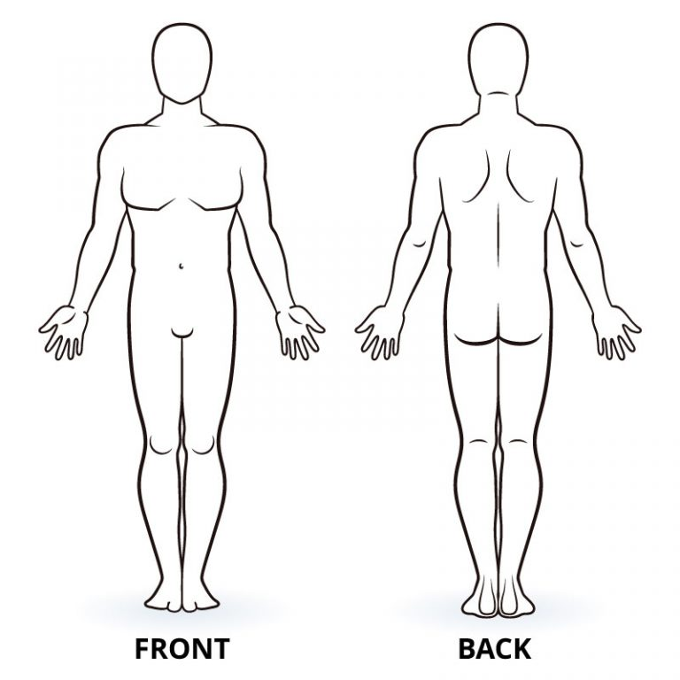

**Pain Quality:**

* None
* Aching
* Burning
* Cramping
* Deep
* Dull
* Numbness
* Radiating

- Where? ________________

* Sharp
* Shooting
* Stiffness
* Tightness
* Tingling

Mark any areas of complaint

**Pain Relieved By:**

Exercise Heat

Ice Lifting

Lying Down Medication

Resting Sitting

Standing Stretching

Walking None of the Above

**Pain Aggravated By:**

Bending Driving

Exercising Getting up/down

House Work Increased Activity

Lifting Looking Down

Lying Down Overhead Activities

Reaching Sitting

Sneezing/Coughing Standing

Walking None of the Above